**Customer Retention Case Study**

**Project Report**

**E-retail factors for customer activation and retention:**

* **A case study from Indian e-commerce customers**

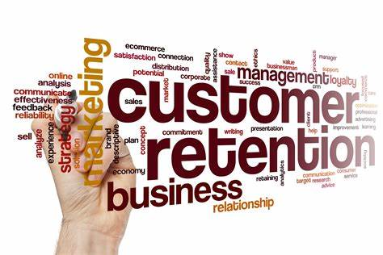

**Submission By**

**Pratiksha Potghan**

**Internship 30**

**Flip Robo Technology**

***Acknowledgement***

It is my pleasure and gratification to present this report. Working on this project was a great experience that gave me very informative knowledge of data analysis.

Flip Robo Technologies (Bangalore) provided all the required information and dataset, which helped me complete the project.

I want to thank my SME Mohd. Kashif for giving me the dataset and instructions to perform the complete case study process.

INTRODUCTION

**Problem Statement:**

Customer satisfaction has emerged as one of the most important factors that guarantee the success of online store; it has been posited as a key stimulant of purchase or repurchase intentions and customer loyalty.

A comprehensive review of the literature, theories and models have been carried out to propose the models for customer activation and customer retention.

Five major factors that contributed to the success of an e-commerce store have been identified as: *service quality, system quality, information quality, trust and net benefit*.

The research furthermore investigated the factors that influence the online customers repeat purchase intention. The combination of both utilitarian value and hedonistic values are needed to affect the repeat purchase intention (loyalty) positively.

The data is collected from the Indian online shoppers.

Results indicate the e-retail success factors, which are very much critical for customer satisfaction.

**CASE DIAGRAM:**

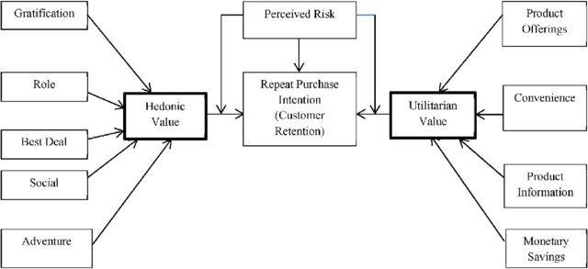

In the above use case diagram, we can see that the Repeat Purchase Intention basically our Customer Retention strategy relies on Hedonic value and Utilitarian value. Also, we see that there are perceived risks affecting the purchase and re purchase intentions of our customers. The Hedonic value has 5 major parts such as gratification, role, best deal, social aspect and adventure feeling criterions. Where as in Utilitarian value we have product offerings, convenience, product information and monetary savings.

***Motivation for the Problem Undertaken*:**

* Our main objective of doing this project is to analyze whether the users are shopping products from e-commerce websites.
* How did they give feedbacks to these websites on the basis of several positive and negative factors and also the details of the users on basis of factors like age, gender, city etc.

***Benefits of Customer Retention:***

* ***Increased profits:***

*Many companies generate the majority of their revenue from existing customers—*[*61% of SMBs*](http://www.biakelsey.com/small-business-owners-shift-investment-from-customer-acquisition-to-customer-engagement-new-report-by-manta-and-biakelsey/)*said this was the case, per a BIA/Kelsey report—so focusing on this part of your business should be the priority. It will not only increase your revenue, but also your*[*business’s profitability*](https://www.netsuite.com/portal/resource/articles/business-strategy/maximize-profitability.shtml)*.*

* ***Lower costs:***

*Retaining an existing customer is anywhere from 5-25 times cheaper than acquiring a new one,*[*according to Bain & Company*](https://media.bain.com/Images/BB_Prescription_cutting_costs.pdf)*, so it’s a much more cost-effective strategy in the long run.*

* ***Increased average order value (AOV):***

*Repeat customers tend to spend more over time while increasing their average order value. That’s why just a 5% increase in retention rate can lead to profits growing 25-95%, per Bain & Company. And loyal customers are 23% more likely to buy again than others,*[*according to a Gallup study*](https://www.gallup.com/workplace/311870/customer-centricity.aspx)*.*

* ***Acquire brand ambassadors:***

*Word of mouth is one of the best ways to grow your business organically. The more loyal your customers, the more likely that they’ll share positive experiences and recommend your company to others.*

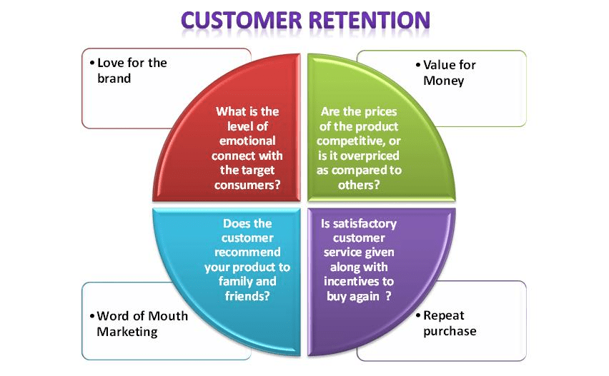

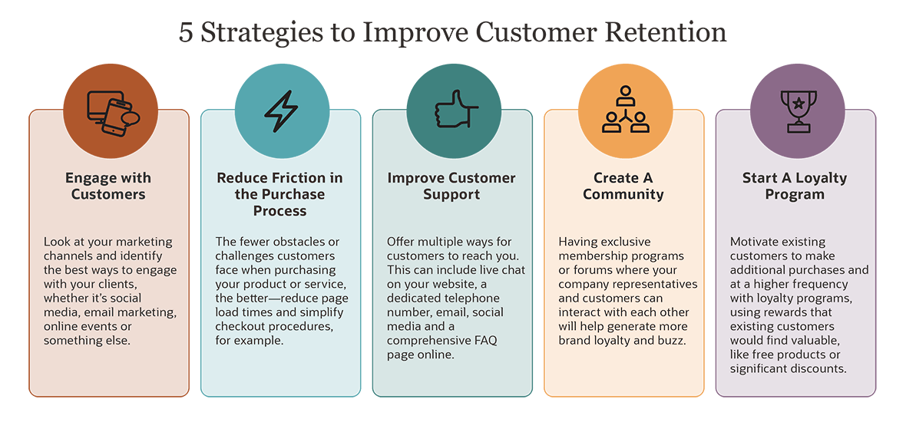

**Performed Data Analysis using the Dataset provided:**

First, I imported all the necessary libraries.

* ***Importing the required libraries***

import pandas as pd

import numpy as np

import seaborn as sns

import warnings

warnings.filterwarnings("ignore")

import os

# *Loading the dataset*

df=pd.read_excel(r'Downloads\customer_retention_datasetnew.xlsx')

df

# EDA - Exploratory Data Analysis

**df.shape**

> Our dataset has 269 rows and 71 columns.

> This dataset is the collection of the questionnaire which was asked in survey of online retailers in Indian Market.

**- All the columns of the dataset are:**

1. Gender of respondent
2. How old are you?
3. Which city do you shop online from?
4. What is the Pin Code of where you shop online from?
5. Since How Long You are Shopping Online?
6. How many times you have made an online purchase in the past 1 year?
7. How do you access the internet while shopping on-line?
8. Which device do you use to access the online shopping?
9. What is the screen size of your mobile device?
10. What is the operating system (OS) of your device?
11. What browser do you run on your device to access the website?
12. Which channel did you follow to arrive at your favorite online stole for the first time?
13. After first visit, how do you reach the online retail store?
14. How much time do you explore the e- retail store before making a purchase decision?
15. What is your preferred payment Option?
16. How frequently do you abandon (selecting an items and leaving without making payment) your shopping cart?
17. Why did you abandon the “Bag”, “Shopping Cart”?
18. The content on the website must be easy to read and understand
19. Information on similar product to the one highlighted is important for product comparison
20. Complete information on listed seller and product being offered is important for purchase decision.
21. All relevant information on listed products must be stated clearly
22. Ease of navigation in website
23. Loading and processing speed
24. User friendly Interface of the website
25. Convenient Payment methods
26. Trust that the online retail store will fulfill its part of the transaction at the stipulated time
27. Empathy (readiness to assist with queries) towards the customers
28. Being able to guarantee the privacy of the customer
29. Responsiveness, availability of several communication channels (email, online rep, twitter, phone etc.)
30. Online shopping gives monetary benefit and discounts
31. Enjoyment is derived from shopping online',
32. Shopping online is convenient and flexible',
33. Return and replacement policy of the e-tailer is important for purchase decision',
34. Gaining access to loyalty programs is a benefit of shopping online',
35. Displaying quality Information on the website improves satisfaction of customers',
36. User derive satisfaction while shopping on a good quality website or application',
37. Net Benefit derived from shopping online can lead to users satisfaction',
38. User satisfaction cannot exist without trust',
39. Offering a wide variety of listed product in several category',
40. Provision of complete and relevant product information',
41. Monetary savings',
42. The Convenience of patronizing the online retailer',
43. Shopping on the website gives you the sense of adventure',
44. Shopping on your preferred e-tailer enhances your social status',
45. You feel gratification shopping on your favorite e-tailer
46. Shopping on the website helps you fulfill certain roles',
47. Getting value for money spent
48. From the following, tick any (or all) of the online retailers you have shopped from
49. Easy to use website or application',
50. Visual appealing web-page layout
51. Complete, relevant description information of products',
52. Fast loading website speed of website and application',
53. Reliability of the website or application',
54. Quickness to complete purchase
55. Availability of several payment options
56. Privacy of customers’ information
57. Security of customer financial information
58. Perceived Trustworthiness',
59. Presence of online assistance through multi-channel',
60. Longer time to get logged in (promotion, sales period)',
61. Longer time in displaying graphics and photos (promotion, sales period)',
62. Late declaration of price (promotion, sales period)',
63. Longer page loading time (promotion, sales period)',
64. Limited mode of payment on most products (promotion, sales period)',
65. Longer delivery period
66. Frequent disruption when moving from one page to another',
67. Website is as efficient as before',
68. Which of the Indian online retailer would you recommend to a friend?
69. Wild variety of product on offer
70. Change in website/Application design
71. Speedy order delivery

**We will take our few of columns for the analysis.**

* **Age :-**

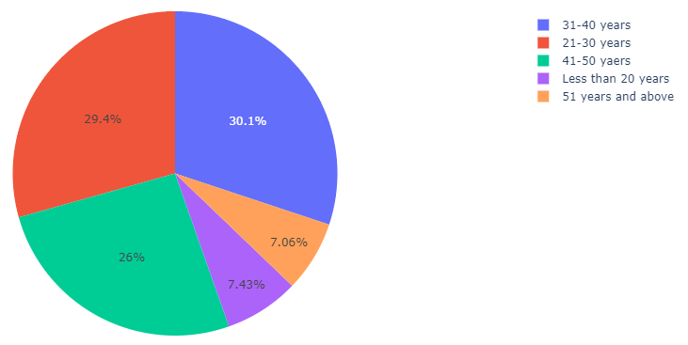

From the plots we can clearly see that most of the respondents fall into the following three categories: -

1. 31-40 years

2. 21-30 years

3. 41-50 years

Very few respondents fall into the categories: -

1. Less than 20 years

2. 51 years and above

* **Different browser used by the people for online shopping:-**

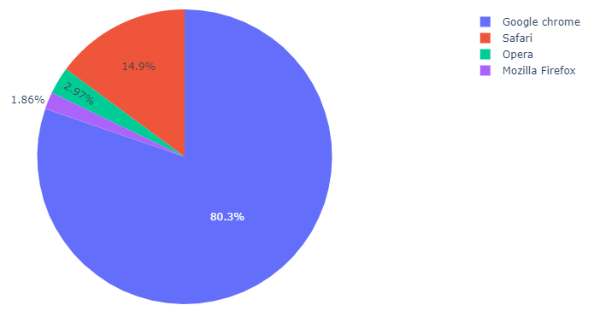

* We can see that mostly people use "**Google chrome**" followed by "Safari".
* Very less people use "**Mozilla Firefox**" & "**Opera**".
* **Fastest loading and Responsive website:-**

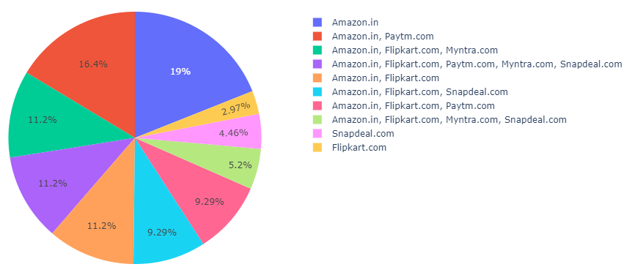Our fastest loading and responsive website are in following order:

**1. Amazon**

**2. Paytm**

**3. Myntra**

**4. Flipkart.**

* **Device used for the Shopping:-**

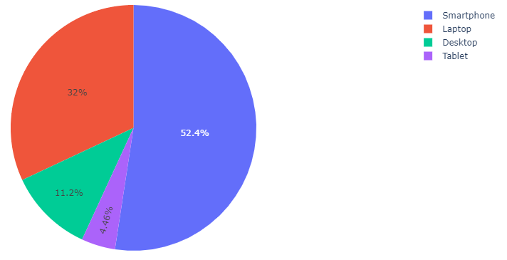

We can see that most people use Smartphone followed by the laptop for the online shopping.

* **GENDER:**

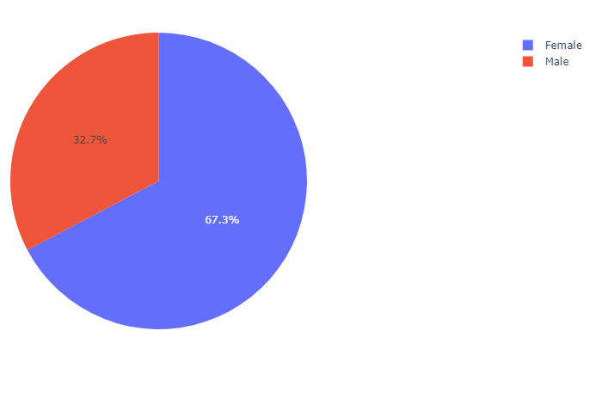

We can see that out of all respondents most people are from female gender.

* **PAYMENT METHOD FOR ONLINE SHOPPING:-**

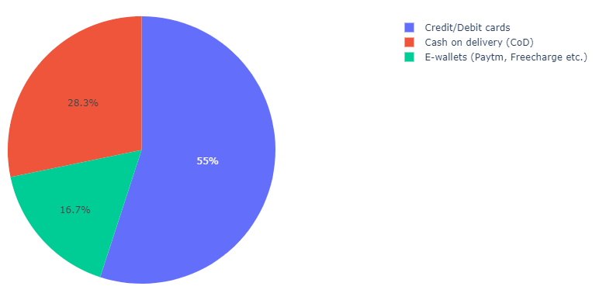

* We can see that most of people use Credit card /Debit Cards for the payment followed by COD (cash on delivery).
* Very few people go for the E-wallet payment method.
* **Best Online shopping Platform for Recommendation to Others:-**

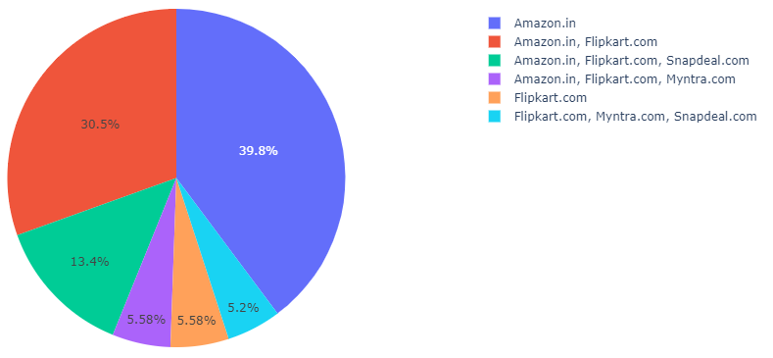

Amazon is the most recommended website followed by the Flipkart.

**Conclusion:**

* Based on overall observations, the data explained how the online platform has been used more often in which CITY, PIN CODE, AGE etc.
* It also showed that in some factors there is less importance given to contribute to the success of an e-commerce store, also we could improve some of the factors that influence the online customers repeat purchase intention.
* Based on the case study for customer activation & retention, Amazon is most reliable and it has fulfilled the customer requirements.
* After Amazon, Flipkart has been used more for online shopping.
* The case study from Indian e-commerce customers showed Amazon and Flipkart has been used mostly for Online Shopping and most recommended by Friends.
* Based on the research factors, Amazon & Flipkart are the e-commerce platform, that are having the combination of both utilitarian and hedonistic values to keep the repeat purchase intention (loyalty) positively.